**Chapter 5**

**Input/ Output and Forms Design**

**5.1 Introduction**

A form is a document with spaces (also named fields or placeholders) in which to write or select, for a series of documents with similar contents. There are several types of forms. Action form, memory form and report form. An action form is that which tells the uses to do something. For example, purchase orders, application form etc. A memory form is the form to keep records. For example, inventory record, journal sheet etc. A report form guides the supervisor and administrator to do something. For example, balance sheet, operating statement etc. Forms are the primary condition of data processing. If all necessary data are properly included in forms, future work with those data becomes easier. Forms must be well-defined so that the person for whom the forms were designed can easily and comfortably give required information. In recent times, digitized forms becomes very popular.

**5.2 Form Design For Bangladesh Telecommunication Company Limited**

In the process of system analysis in Bangladesh Telecommunication Company Limited several types of forms were required.Such are Leased Line Internet Form, Leased Line Internet Agreement Form, VPN Application Form, VPN Agreement Form, Telephone Application Form. The forms can be filled up online or offline.

**Leased Line Internet Form**

People can apply for Dedicated Bandwidth with this Application form.

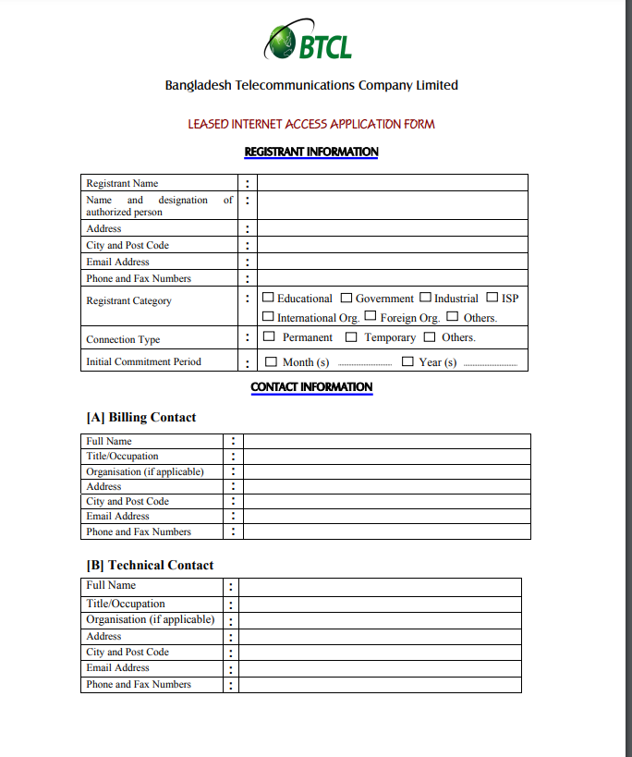

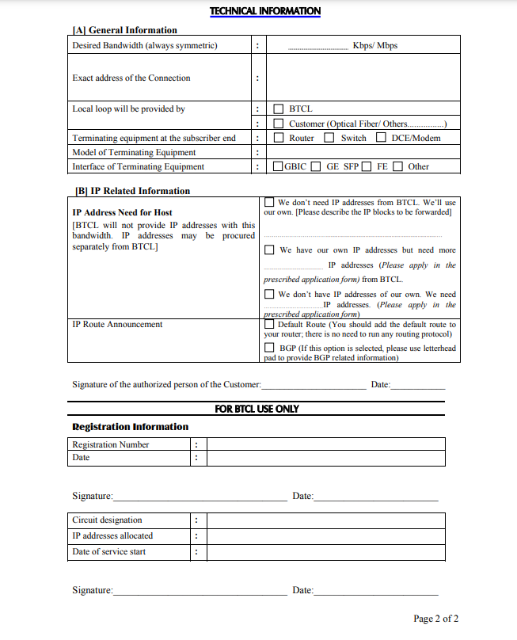

**Leased Line Internet Agreement Form**

One needs to sign in this LLI Agreement form and to submit with the application.

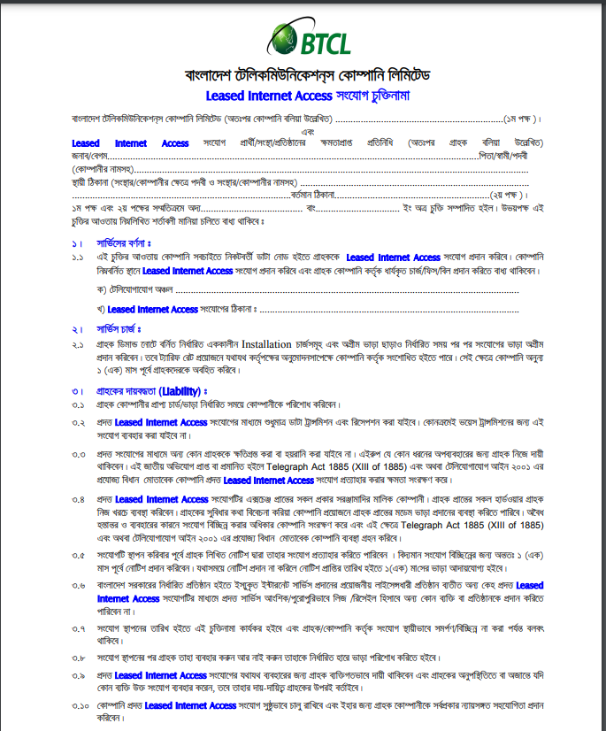

**VPN Application Form**

People can apply for VPN connection with this Application form.

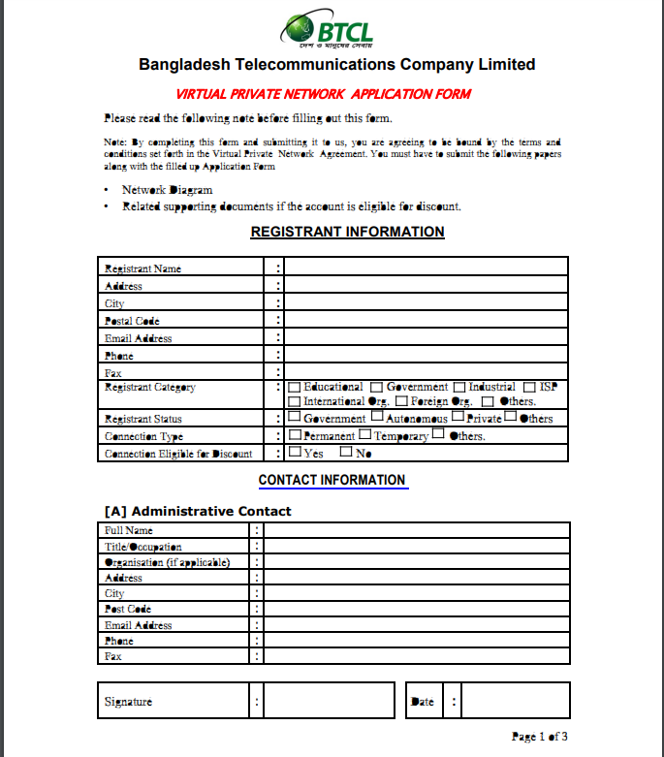

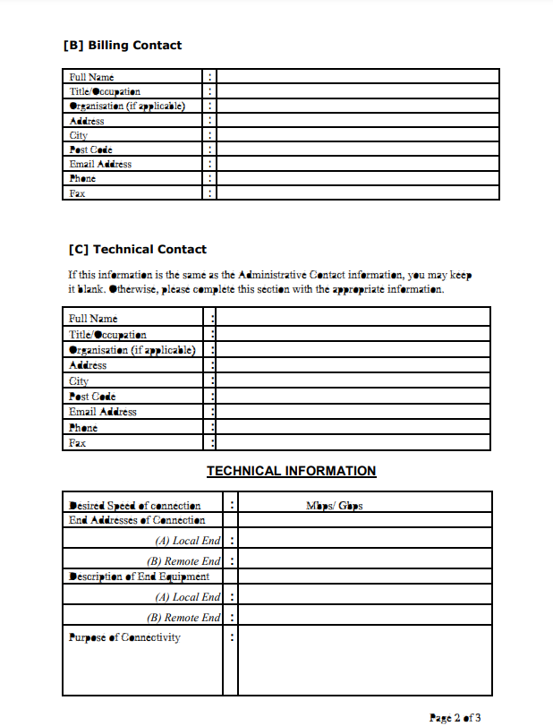

**VPN Agreement Form**

One needs to sign in this VPN Agreement form and to submit with the application.

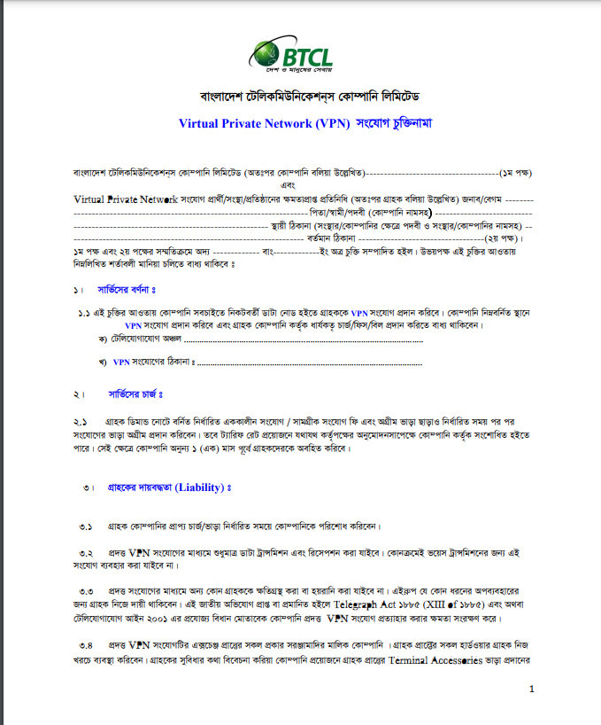

**Telephone Application Form**

People can apply for Telephoen and GPON with this Application form.

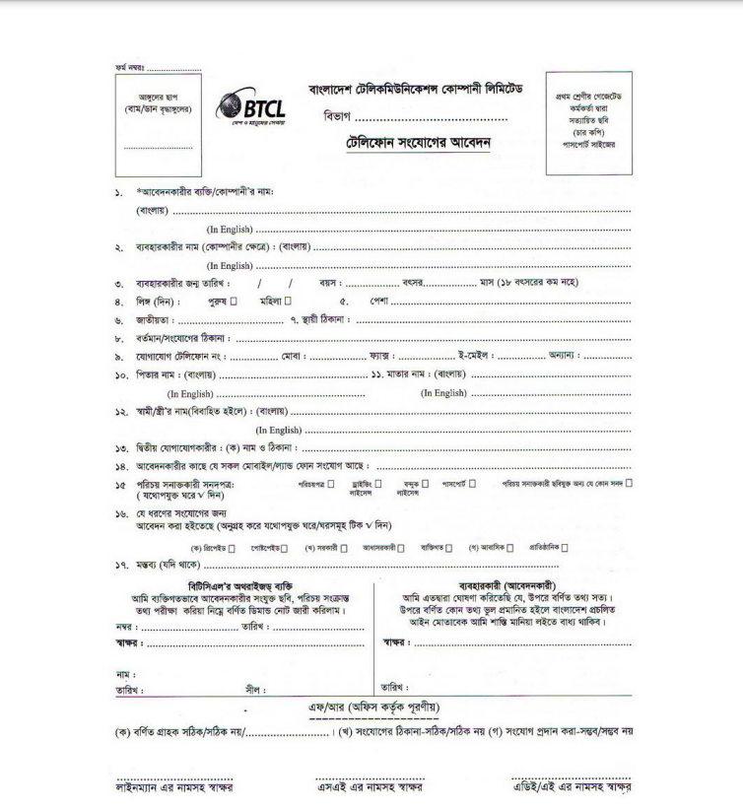

**5.3Conclusion**

The forms are essential medium for establishing an effective database system. An effective database system can ensure better performance for a system. As the company has to maintain a huge amount of data, the forms and database system must be effective and redundancy free.Every year the number of users is increasing and handling those amount of data is becoming quite complex process. Keeping those conditions under considerations, those proposed forms were designed.But these forms need a robust and secured digital system with proper fail safe measurement.As the amount of data is increasing every year, these forms may be changed after a certainperiod of time. But as the forms are interacting with the central database, the modification needs to be handles properly. The forms are designed to process digitally. So, a digital system must be designed to implement those forms in use. The implementation can be done using a website or a software. Since the form will be interacting with the central database and the result system is a very confidential process, a separate software with the ability to interact with the database is recommended. But this process needs a qualified expert team and regular maintenance. A technical support team can be appointed for this purpose.